New BCD added - CarTrawler/ETrawler (BCD# T788900)

We have added a new organization for prepaid rentals under BCD#T788900. This BCD, however, is used in two different scenarios.

Case 1: Delivered with a voucher amount on the Comments tab and a KRNM rate (or a Wizard rack rate).

Please note that KRNM is a rate automatically created by GIS because the original Wizard reservation was not delivered with a rate name.

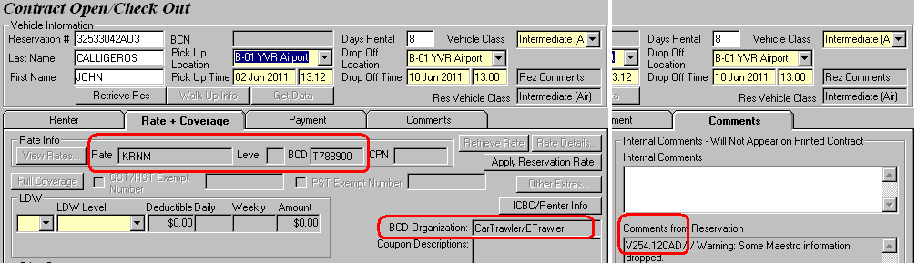

Any time you see a voucher amount (starting with a ‘V’ and ending with a currency) under Comments for this BCD, you should know that it is a prepaid rental. Therefore, you must record the voucher amount in the Voucher/Certificate window, as shown in the following screenshot. Charge the remaining balance and optional extras (if any) to the customer’s credit card.

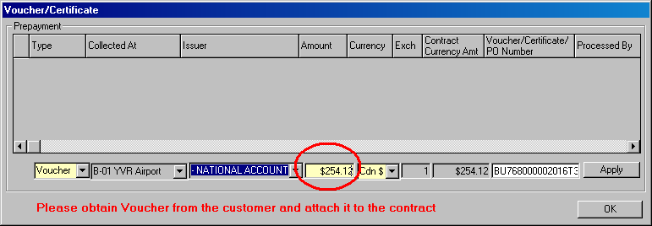

Case 2: Delivered with no voucher amount on the Comments tab and a Wizard rack rate

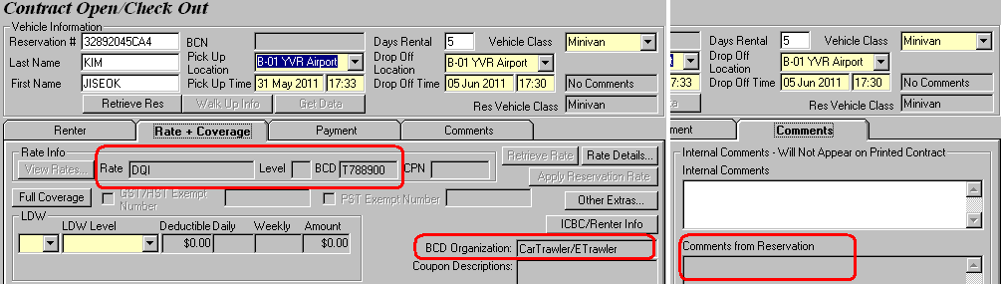

In this scenario, open this reservation as you would any other Wizard reservations.

